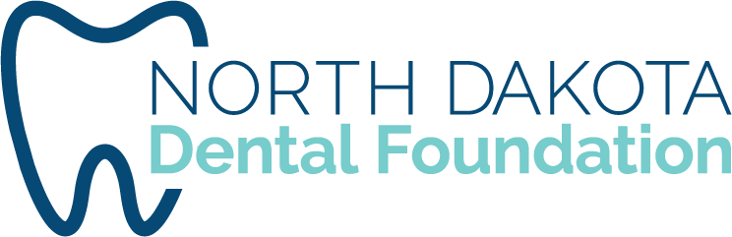

Policy: Dental Assistant Grant Reimbursement
Approved by: North Dakota Dental Foundation Board
Approved on: 12/3/2024
Updated on: 11/19/2024

Dental Assisting DA Prep Course, DANB Prep, and DANB Exam Reimbursement
Total Reimbursement to be granted, per individual, not to exceed $1,250 combined for the following three requests:
- Reimbursement to be granted, per individual, for Dental Assisting National Board (DANB) exams (three-part DANB CDA exams or three-part DANB NELDA exams), not be reimbursed for graduates of CODA-accredited DA programs; only Dental Assistants that are challenging DANB exams following or concurrently with clinical dental office practice hours will be eligible. The applicant must provide proof of successful test completion, any failed test attempts will not be considered for reimbursement and only one practice test per exam will be considered for approval. A North Dakota Qualified Dental Assistant (QDA) or Registered Dental Assistant (RDA) registration certificate needs to be included along with the ND license number. Prior to reimbursement, receipts need to be provided, and the name must match the reimbursee.

- Reimbursement to be granted, per individual, for DANB/DALE Foundation review courses and/or practice tests will be granted. The applicant must have proof of completing the Dental Assisting National Board (DANB) exams of the study materials purchased. Prior to reimbursement, receipts need to be provided, and the name must match the reimbursee.

- Reimbursement to be granted, per individual, for the DA Prep, Dentist Sponsored Online Course. The applicant must provide proof of course completion and/or a North Dakota Qualified Dental Assistant (QDA) registration certificate. Prior to reimbursement, receipts need to be provided, and the name must match the reimbursee.
Dental Assisting Recruitment Reimbursement
- Any current practicing dental professional in North Dakota or a dental professional affiliated with an accredited teaching program is eligible to receive an honorarium for presentations made at high schools or job fairs if approved by the BFID committee. The target audience are those interested in any dental profession as a career and not currently working in dentistry. The presenter should distribute the Bright Futures in Dentistry documents, and/or information about CODA-accredited ND schools at the event and be knowledgeable about the grant and goals. The honorarium will be $100 for any event up to a half-day in length, and $200 for an all-day event or job fair. Other expenses such as mileage, hotel, and meals may be reimbursed if approved by the committee as well. A narrative that includes the size of the audience, the presentation made and contact info for that school or sponsoring organization must be submitted to the BFID committee prior to the expenses and honorarium being paid.
- Any current practicing dental professional in North Dakota or dental professional affiliated with an accredited teaching program is eligible to receive reimbursement for presenting a face-to-face clinical review course in preparation for DANB certification. The amount of reimbursement will be determined by the Bright Futures in Dentistry Committee on a case- by-case basis pending a narrative description of the course by the presenter and size of the audience.

